THEME: Controlling Many

Puzzle Game

In this particular game the features that I intend to incorporate are:

1. Multiple entities will be controlled by the same user input.
2. The entities will have different puzzles to solve.
3. The movement of each entity may affect the puzzle of the other entity.

Examples of the puzzles:

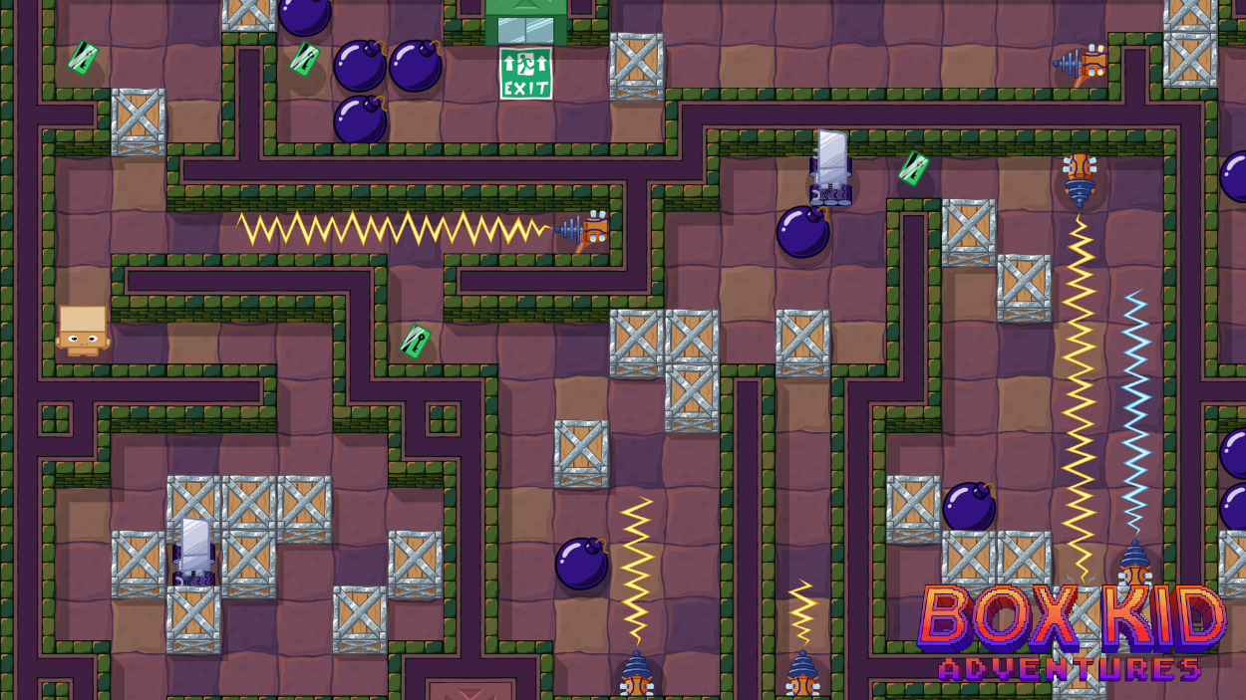

The player will have the option to move up down left right and all the player units will move the same amount in the same direction being blocked only by a wall.

There may be simple puzzles where simply navigating to the objective will lock the box in place. There may be more complex ones where the players movement will open up the path for the other units.

There will be four quadrants and 4 blocks. Once all the blocks are in place the level is cleared. If even one of the blocks dies the level resets.